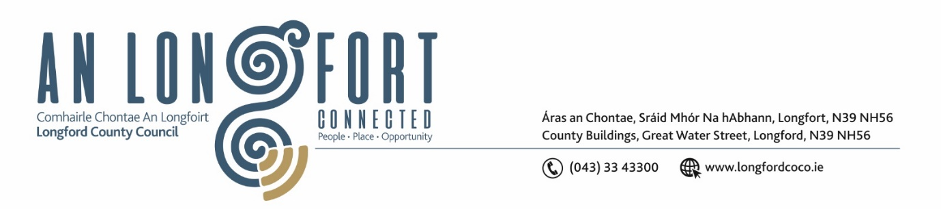

***Please note meeting will be held in the Council Chamber and via Microsoft Teams.***

29 November 2024

**Chuig: Gach Ball don Chomhairle**

A Chomhairleoir,

Iarrtar ort bheith i láthair ag Cruinniú Míosuil Chomhairle Chontae Longfoirt a tionólfar i Seomra na Comhairle, Aras an Chontae, Longford agus via MS Teams are an **De Aoine 06 Nollaig 2024 ag 4pm** chun gnó a dhéanamh d’réir an Chláir thíos.

You are requested to attend the Monthly Meeting of Longford County Council to be held in the **Council Chamber and via Microsoft Teams** on **Friday, 06 December at 4pm** to transact business, as set out on the Agenda hereunder.

Mise le meas,

**__________________**

***Claire McNabola***

***Meetings Administrator***

**C L Á R**

Prayer before meeting.

1. **Confirmation of Minutes**
2. Monthly meeting of Longford County Council held on 13 November 2024 – enclosed.
3. Matters Arising
4. Declaration of Interest by Members
5. To note Management Report (To Follow)
6. To note adopted Minutes of Corporate Policy Group Meeting held on 11 September – enclosed
7. **Finance and Information Technology**
8. Consideration under Section 183, of the Local Government Acts of a Lease to The Trustees of the Ardagh Clock Tower Committee, of Ardagh, Longford, of the property at the Clock Tower, Ardagh, Co.Longford having being acquired from the representatives of the Fetherstone Estate, Ardagh, Co.Longford.
9. **Housing, Planning, Regeneration & Capital Projects**
10. To note planning applications received
11. **Community, Library and Cultural Services, Corporate and Human Resources**
12. Chief Executive Report on Implementation of the Corporate Plan (2019-2024)
13. **Infrastructure, Climate Action & Innovation**

**Notice of Motions set out hereunder:**

1. **Councillor David Cassidy**

I call on Longford County Council to implement a text alert system whereby vehicles parked illegally in designated disabled parking bays can be reported and fined where the blue badge (Disabled Persons Parking Card) is not displayed. Signage to be erected at each parking bay throughout the county with the text alert number for people to report to Longford County Council. Photographic evidence to be provided to the Council along with registration of the vehicle in question.

1. **General**

**Notice of Motions set out hereunder:**

1. **Councillor Paul Ross**

I call on the Minister for Education to provide additional ASD units in secondary schools in the Longford catchment area as current demand is greater than the available places and this is causing great stress to families who are seeking places.

1. I call on Bus Eireann to include a daily college bus route from Edgeworthstown to Athlone to assist students who wish to use public transport to college.
2. **Correspondence**
3. **Votes of Sympathy**
4. **Date and time of next Meeting**